Questionnaire for the bulk product volume and level
measuring systems.
Application number (to be filled in by dealer)
Customer contact details:
Organization
Contact person
Position
E-mail
Phone
Number of tanks: pcs.
Information about the product to be measured:
name
angle of repose deg.
Ex certificates required?
Temperature in the level transmitter installation area: min.°C max. °C
Tank pressure:
Other (relative):
min. max.
Expected configuration:
number of level transmitters per tank:
ULM-3D-5 pcs.
ULM-31/ULM-11 pcs.
Tank type and dimensions:
A | m
B | m
C | m
D | m
E | m
F | m
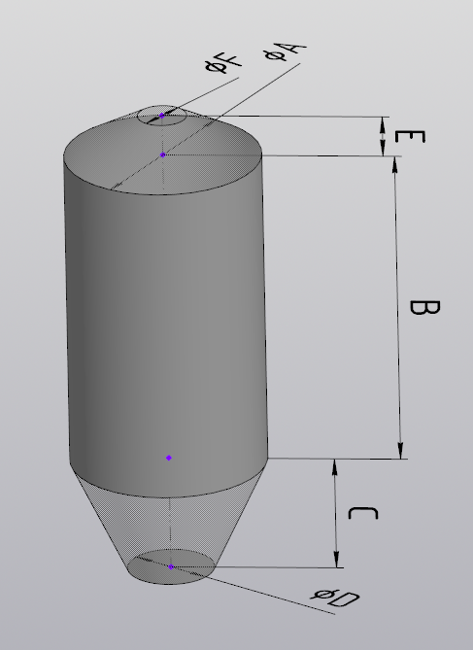
A | m
B | m
C | m
D | m
E | m
F | m
G | m
H | m
I | m
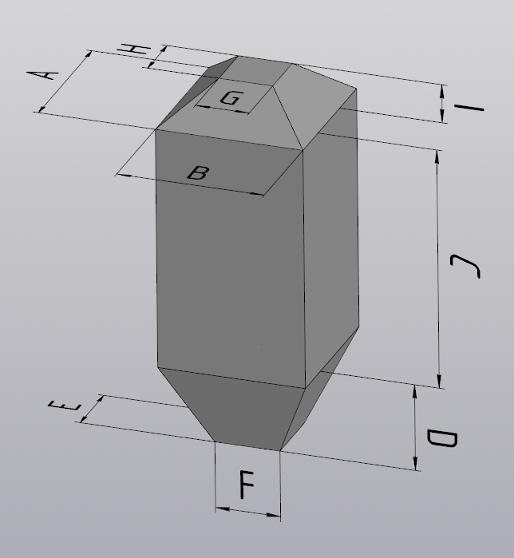

Main differences between the actual tank and the above markedoption:
Describe the main differences between the tank and the standard shape (selected above), if any. If the differences are significant, attach drawings and/or sketches and/or photos indicating the differences or showing the entire tank with the main dimensions.
Detailed information:
Roof:
- It is necessary to attach the roof drawings or sketches (see example below) indicating the following:
- places specified for the level transmitter installation (if any)
- areas allowed for the level transmitter installation
- areasprohibited for the level transmitter installation
- places of backfill\filling with dimensions
-metal structures above and under the roof, indicating the dimensions andlocation.
- Specify the roof thickness (without metal structures, etc.) m.
- Attach photos (if available)
Tank body:
- If there are protruding structures (stairs, stiffeners, etc.) inside the tank, attach drawings and/or sketches and/or photos indicating the structure position and dimensions
Lower part of the tank:
- It is necessary to attach drawings and/or sketches and/or photos of the lower part indicating the following:
- protruding structures (dividers, gates, stiffeners, etc.) with dimensions
- places of unloading/pouring with dimensions

Examples of attachment:
Example 1: rectangular tank roof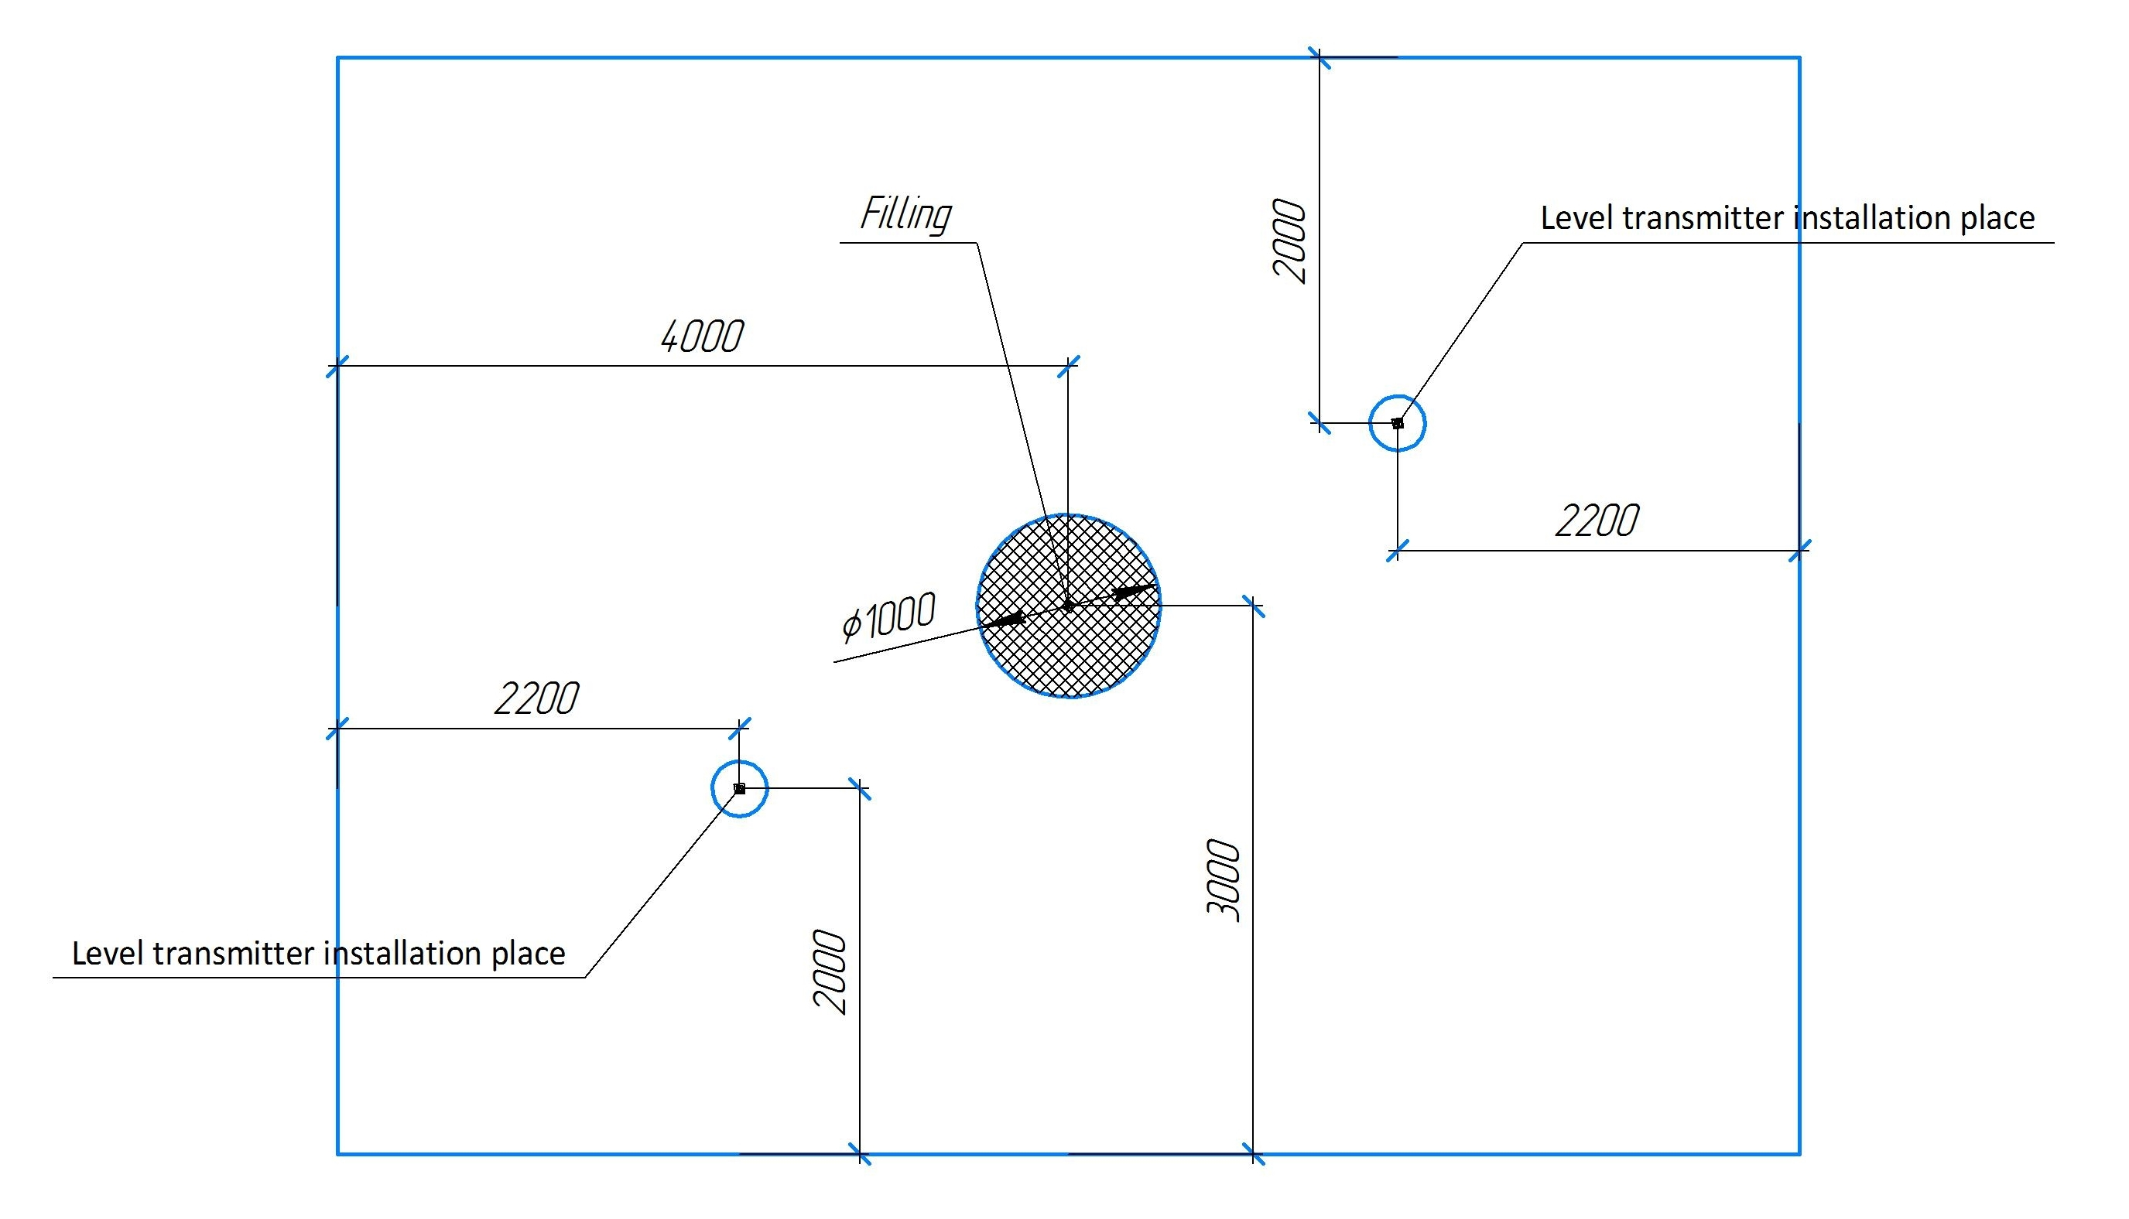
Example 2: circular tank roof 